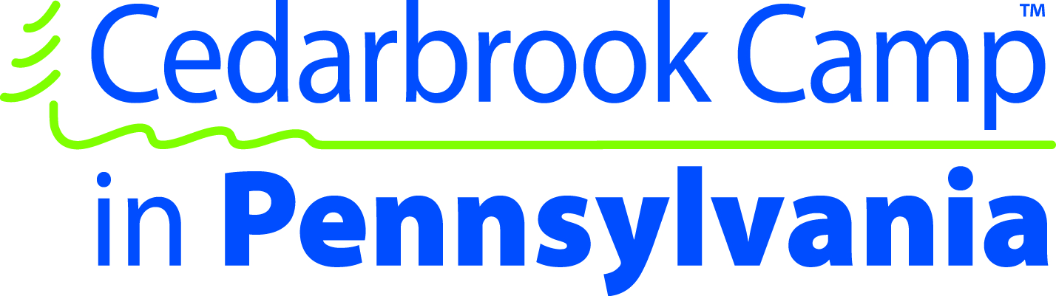

Hi friends of Cedarbrook Camp in Pennsylvania,

What a great summer we had! God did some amazing things and I’m so excited to report to you some of what He did in our campers and staff lives. We know that the work that God is doing is continuing into the year and that there are ways that He is working that we may never know. I praise God for allowing CCPA to be a part of His work and pray that He will continue to pour out his blessings on us as we continue to strive to serve Him and challenge youth to experience the excitement of a Christ-centered life.
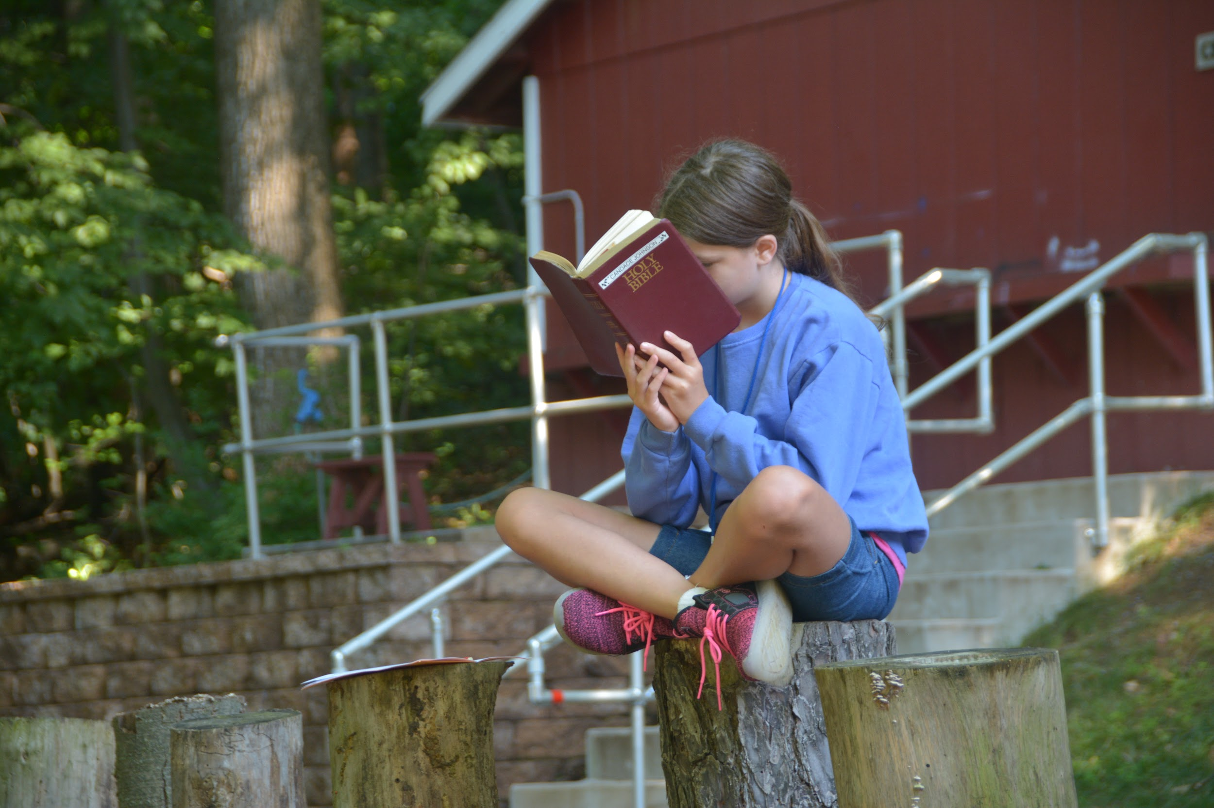
Our spiritual theme for this year was “Reflect”. We learned what it means to reflect God’s love to others as well as the importance of taking time to reflect upon what the Lord has done for us. Reflection in today’s society is a difficult thing as there are so many things competing for our attention. From phones, to school work, to relationships, to sports and everything in between; it can be difficult to put some of those things aside and really reflect upon the Lord. Most of those distractions are not bad things, but they can take our focus off the Lord. But at camp those distractions are purposefully faded. That’s one of my personal favorite things about camp. Many of those distractions are gone and there is time and space to just think about God, pray, and spend time in the Bible studying God’s Word.

Thank you for your investment in CCPA. Whether you contributed financially as a donor, sent your kids for a week or more, volunteered to serve at camp, or prayed for us, YOU are an important part of CCPA. God has used your contributions to further His kingdom. Your prayers helped to prepare hearts, keep us safe, and effectively share God’s love and Word with the campers that were entrusted to us this summer.

Our camper numbers were lower than we anticipated. We were praying for 150 campers and had 124. The most exciting news I can report is when campers make decisions to give their hearts and lives to the Lord and trust in Jesus. I am so thrilled to report that we had

4 campers accept Christ this year!!!

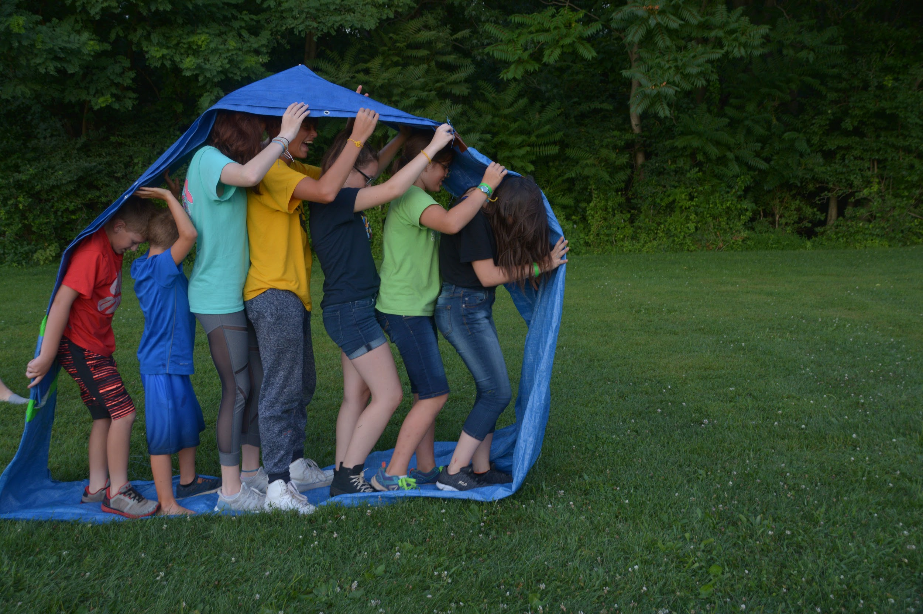
I know that many more lives were impacted and campers made decisions to refocus their lives on Christ. Some tough issues were talked about and prayed over. God was glorified and His love and grace were shared with the campers that were with us this year. Here are some quotes from campers on what they learned this summer.

“They helped me understand that we are all unique and made in the image of God and that God loves us so much”

“My heart was set on God”

“I reflected on God’s love and mercy. God showed me how much He loves me.”

It truly was a great summer. It was not without its struggles especially the weather during girls week. It was the rainiest week I’ve ever experienced, but God provided and we were still able to do our cabin cookouts around the campfire. One theme that became evident during camp for both weeks was flexibility. We had to switch things around both weeks and God gave everyone the patience to be flexible and work through some of the scheduling changes.

Looking forward to 2019
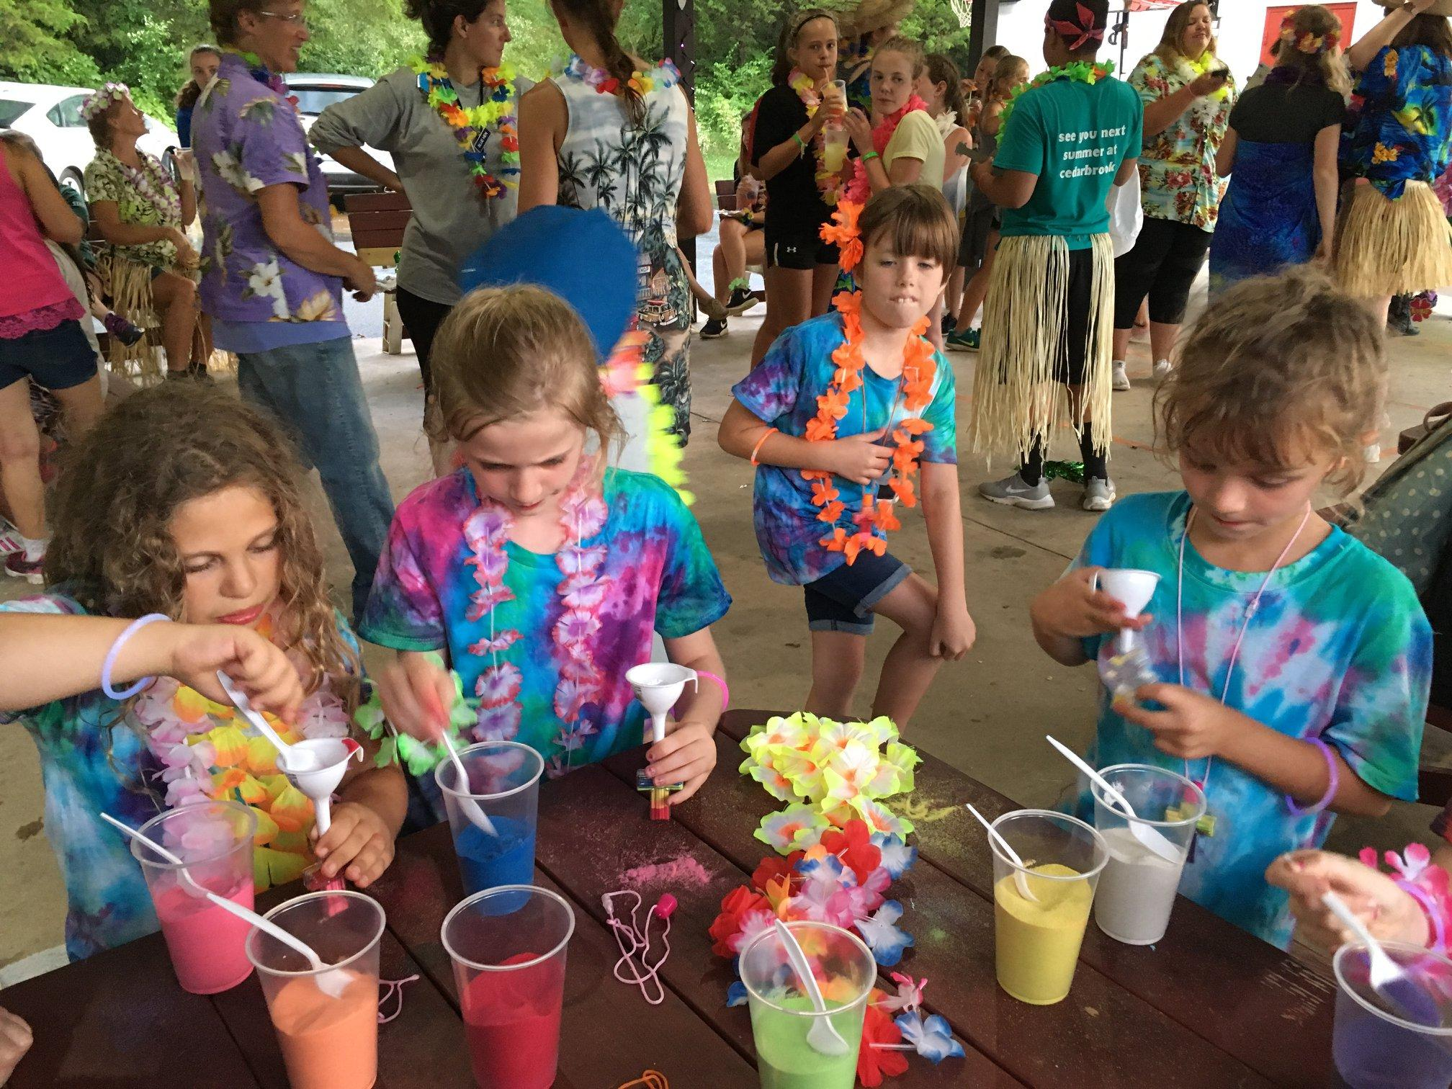
Our theme for 2019 is “All-In”. We will learn what it means to be all in for God and how to give Him glory and honor in all that we do. Our theme verse is Colossians 3:17 - “And whatever you do, in word or in deed, do everything in the name of the Lord Jesus giving thanks to God the Father through Him.”

We will also have a slight schedule change for 2019. We will have our girls week first and coed week second;
July 14-20 Girls Week
July 21-27 Coed Week/CILT week

We will also have our open house/reunion on April 6th from 10am - 4pm. We would love to see you there.

How you can help Cedarbrook Camp in PA:
- Pray, pray, pray! We always need prayers. We know that God has big plans for the 2019 year and we would appreciate your prayers. We already know that we will have people in new roles especially the weekly director roles and would greatly appreciate your prayers as these individuals step out in faith to assume new roles.
- Invite campers to go to camp. As you saw in the report, our campers numbers were low for this year. We are really praying for two full weeks of camp both coed and girls week. So please share about camp with your friends and family.
- Donate. Our campers fees don’t cover the complete cost of camp. We have lodging, food, insurance, program supplies, and many other expenses and we try to keep our camper costs down. We rely on donors! We appreciate all those who have donated and ask you prayerfully consider how you can donate to help keep CCPA reaching kids for Christ for years to come. We have enclosed a self-addressed envelope for your convenience or you can donate on the website at: www.cedarbrookcamppa.org/donate
- Volunteer! We always need some additional hands at camp. Perhaps you would like serving in one of our support roles such as helping to lead activities or help in the dishroom (somewhere we always need servants!). Our staff application will be open when registration opens.
- Join us on April 6th for the reunion and open house. More info will be coming soon on this, but please save the date and join us!
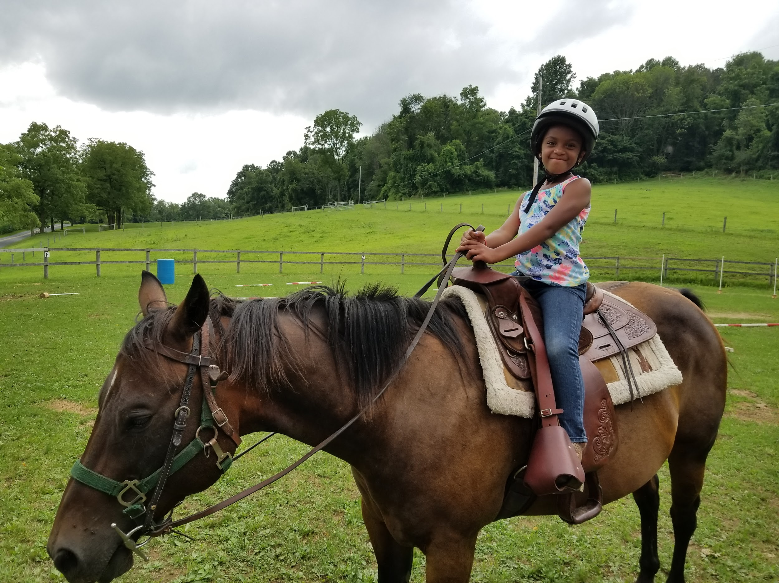
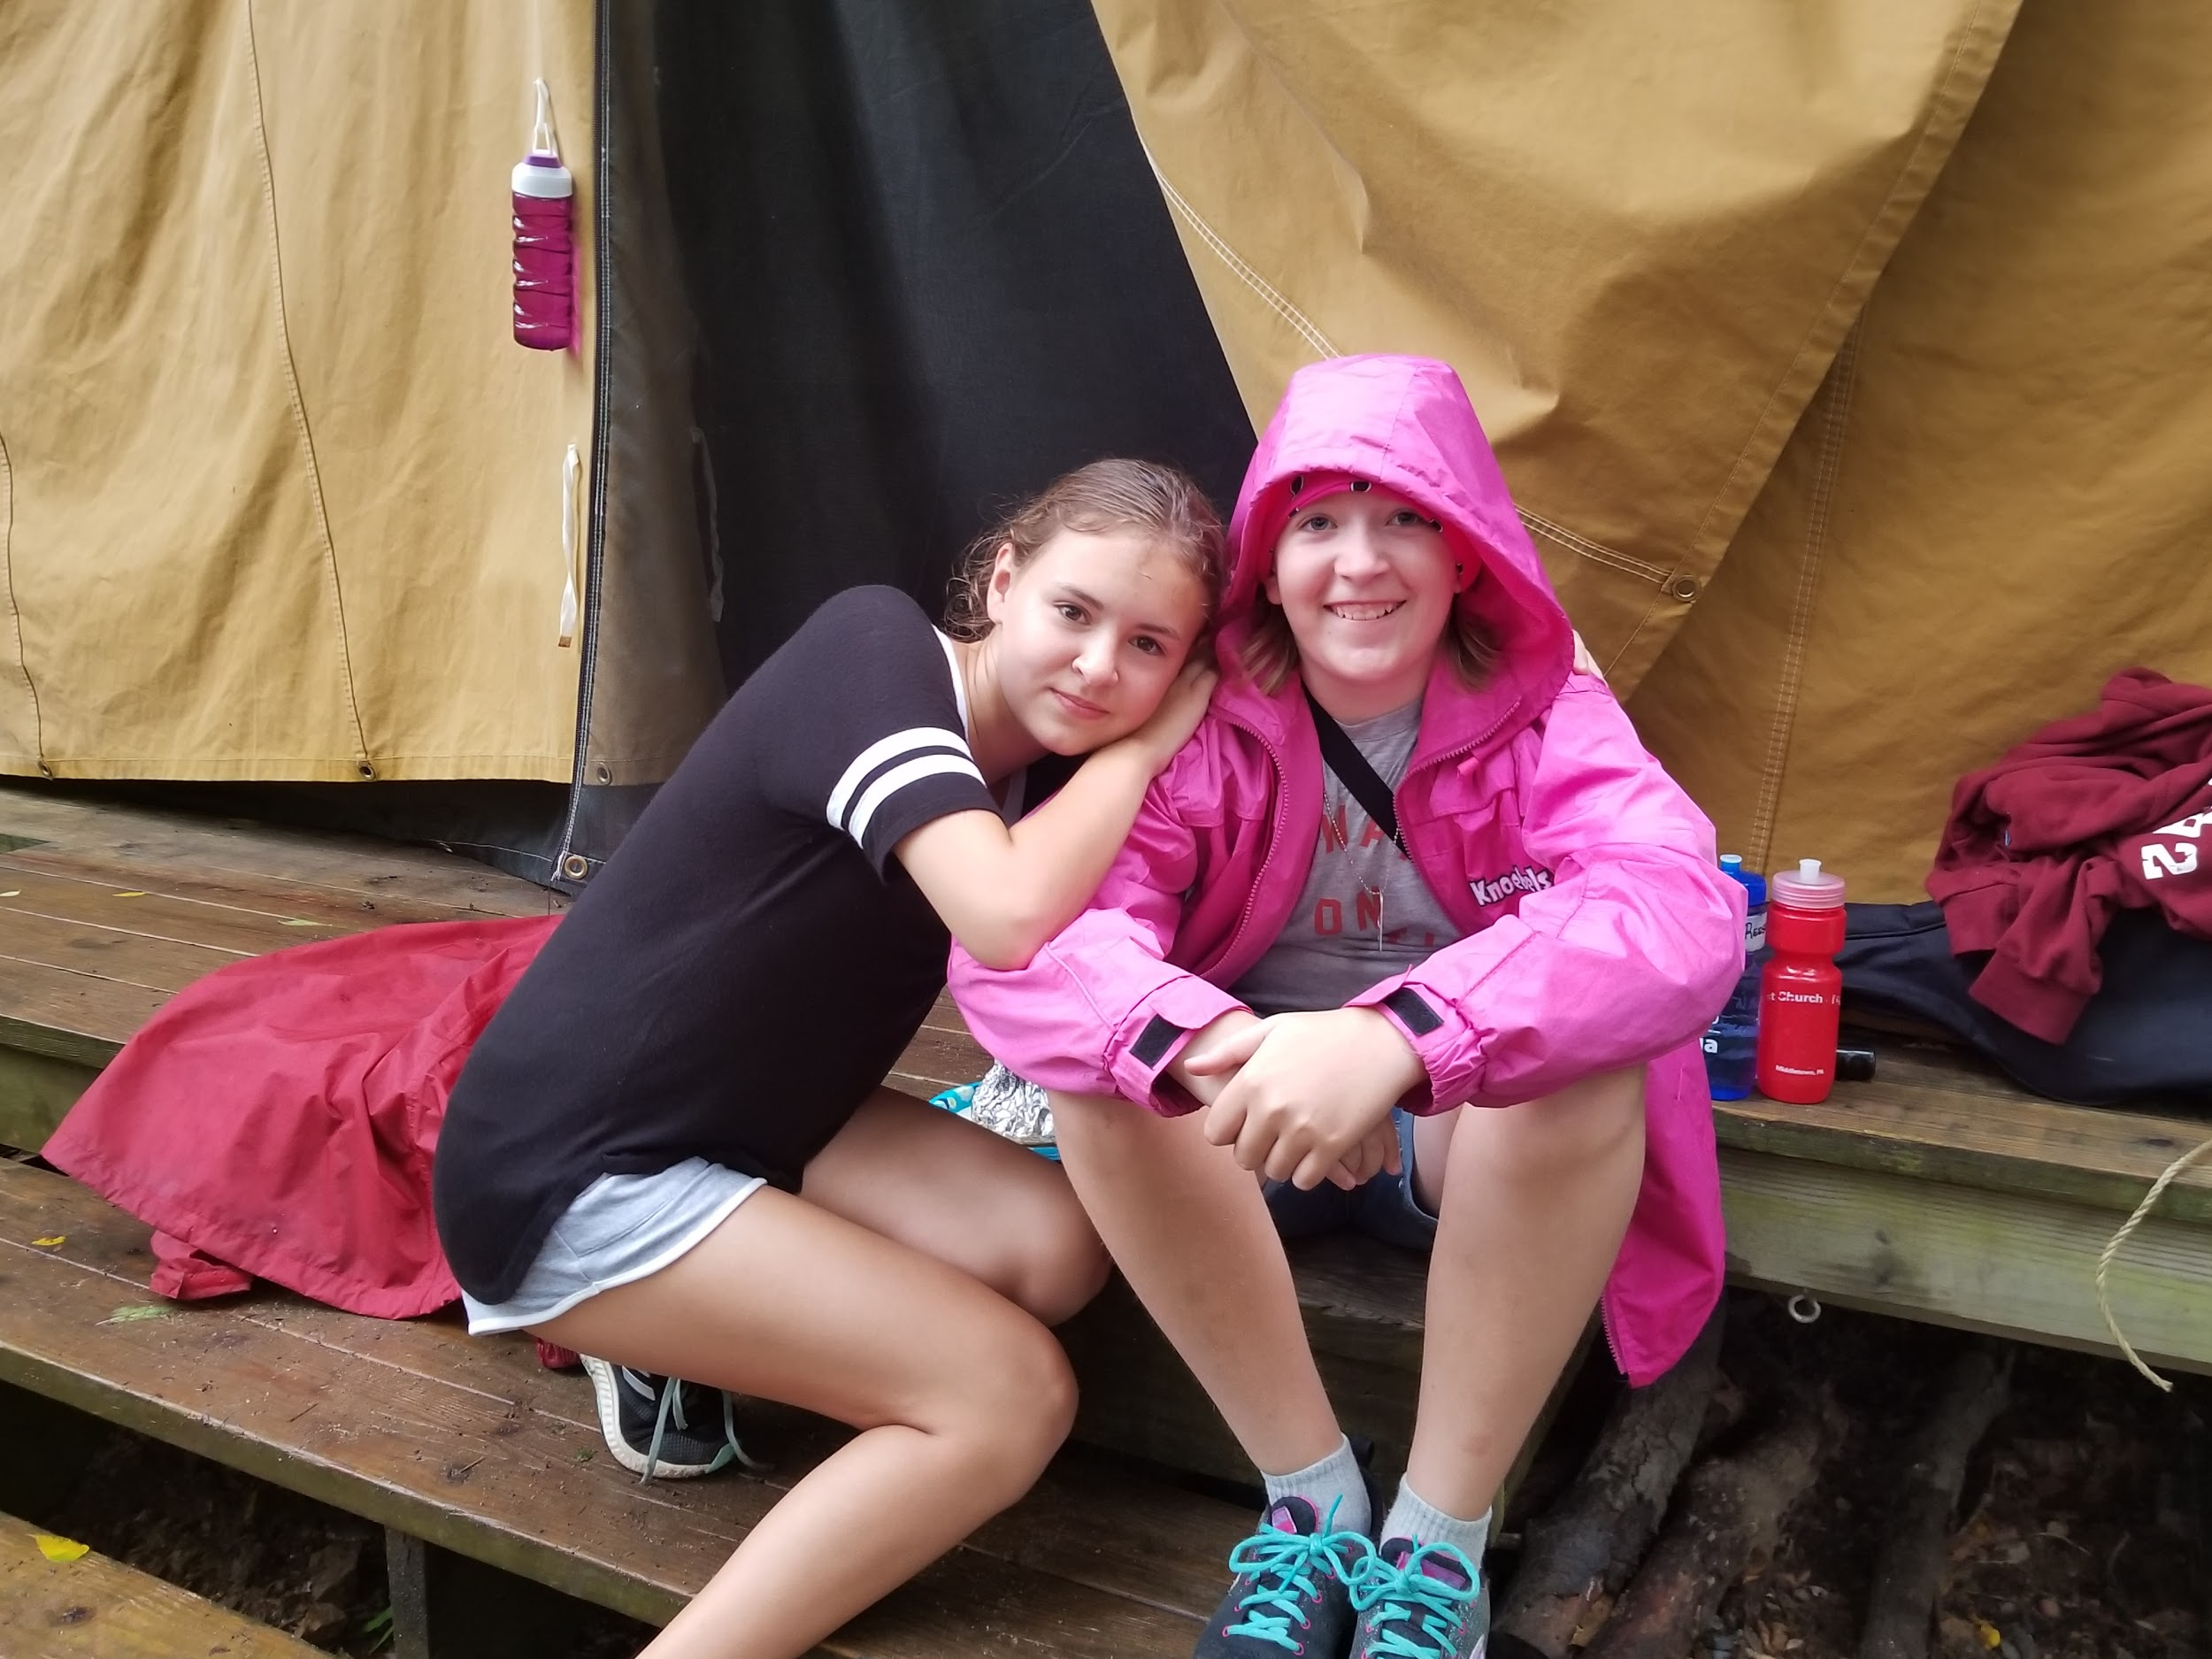

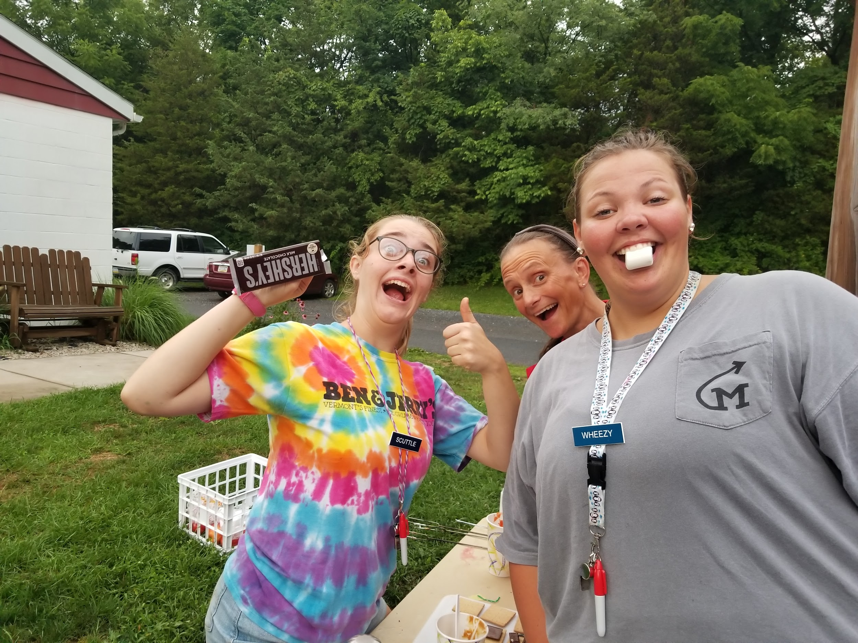
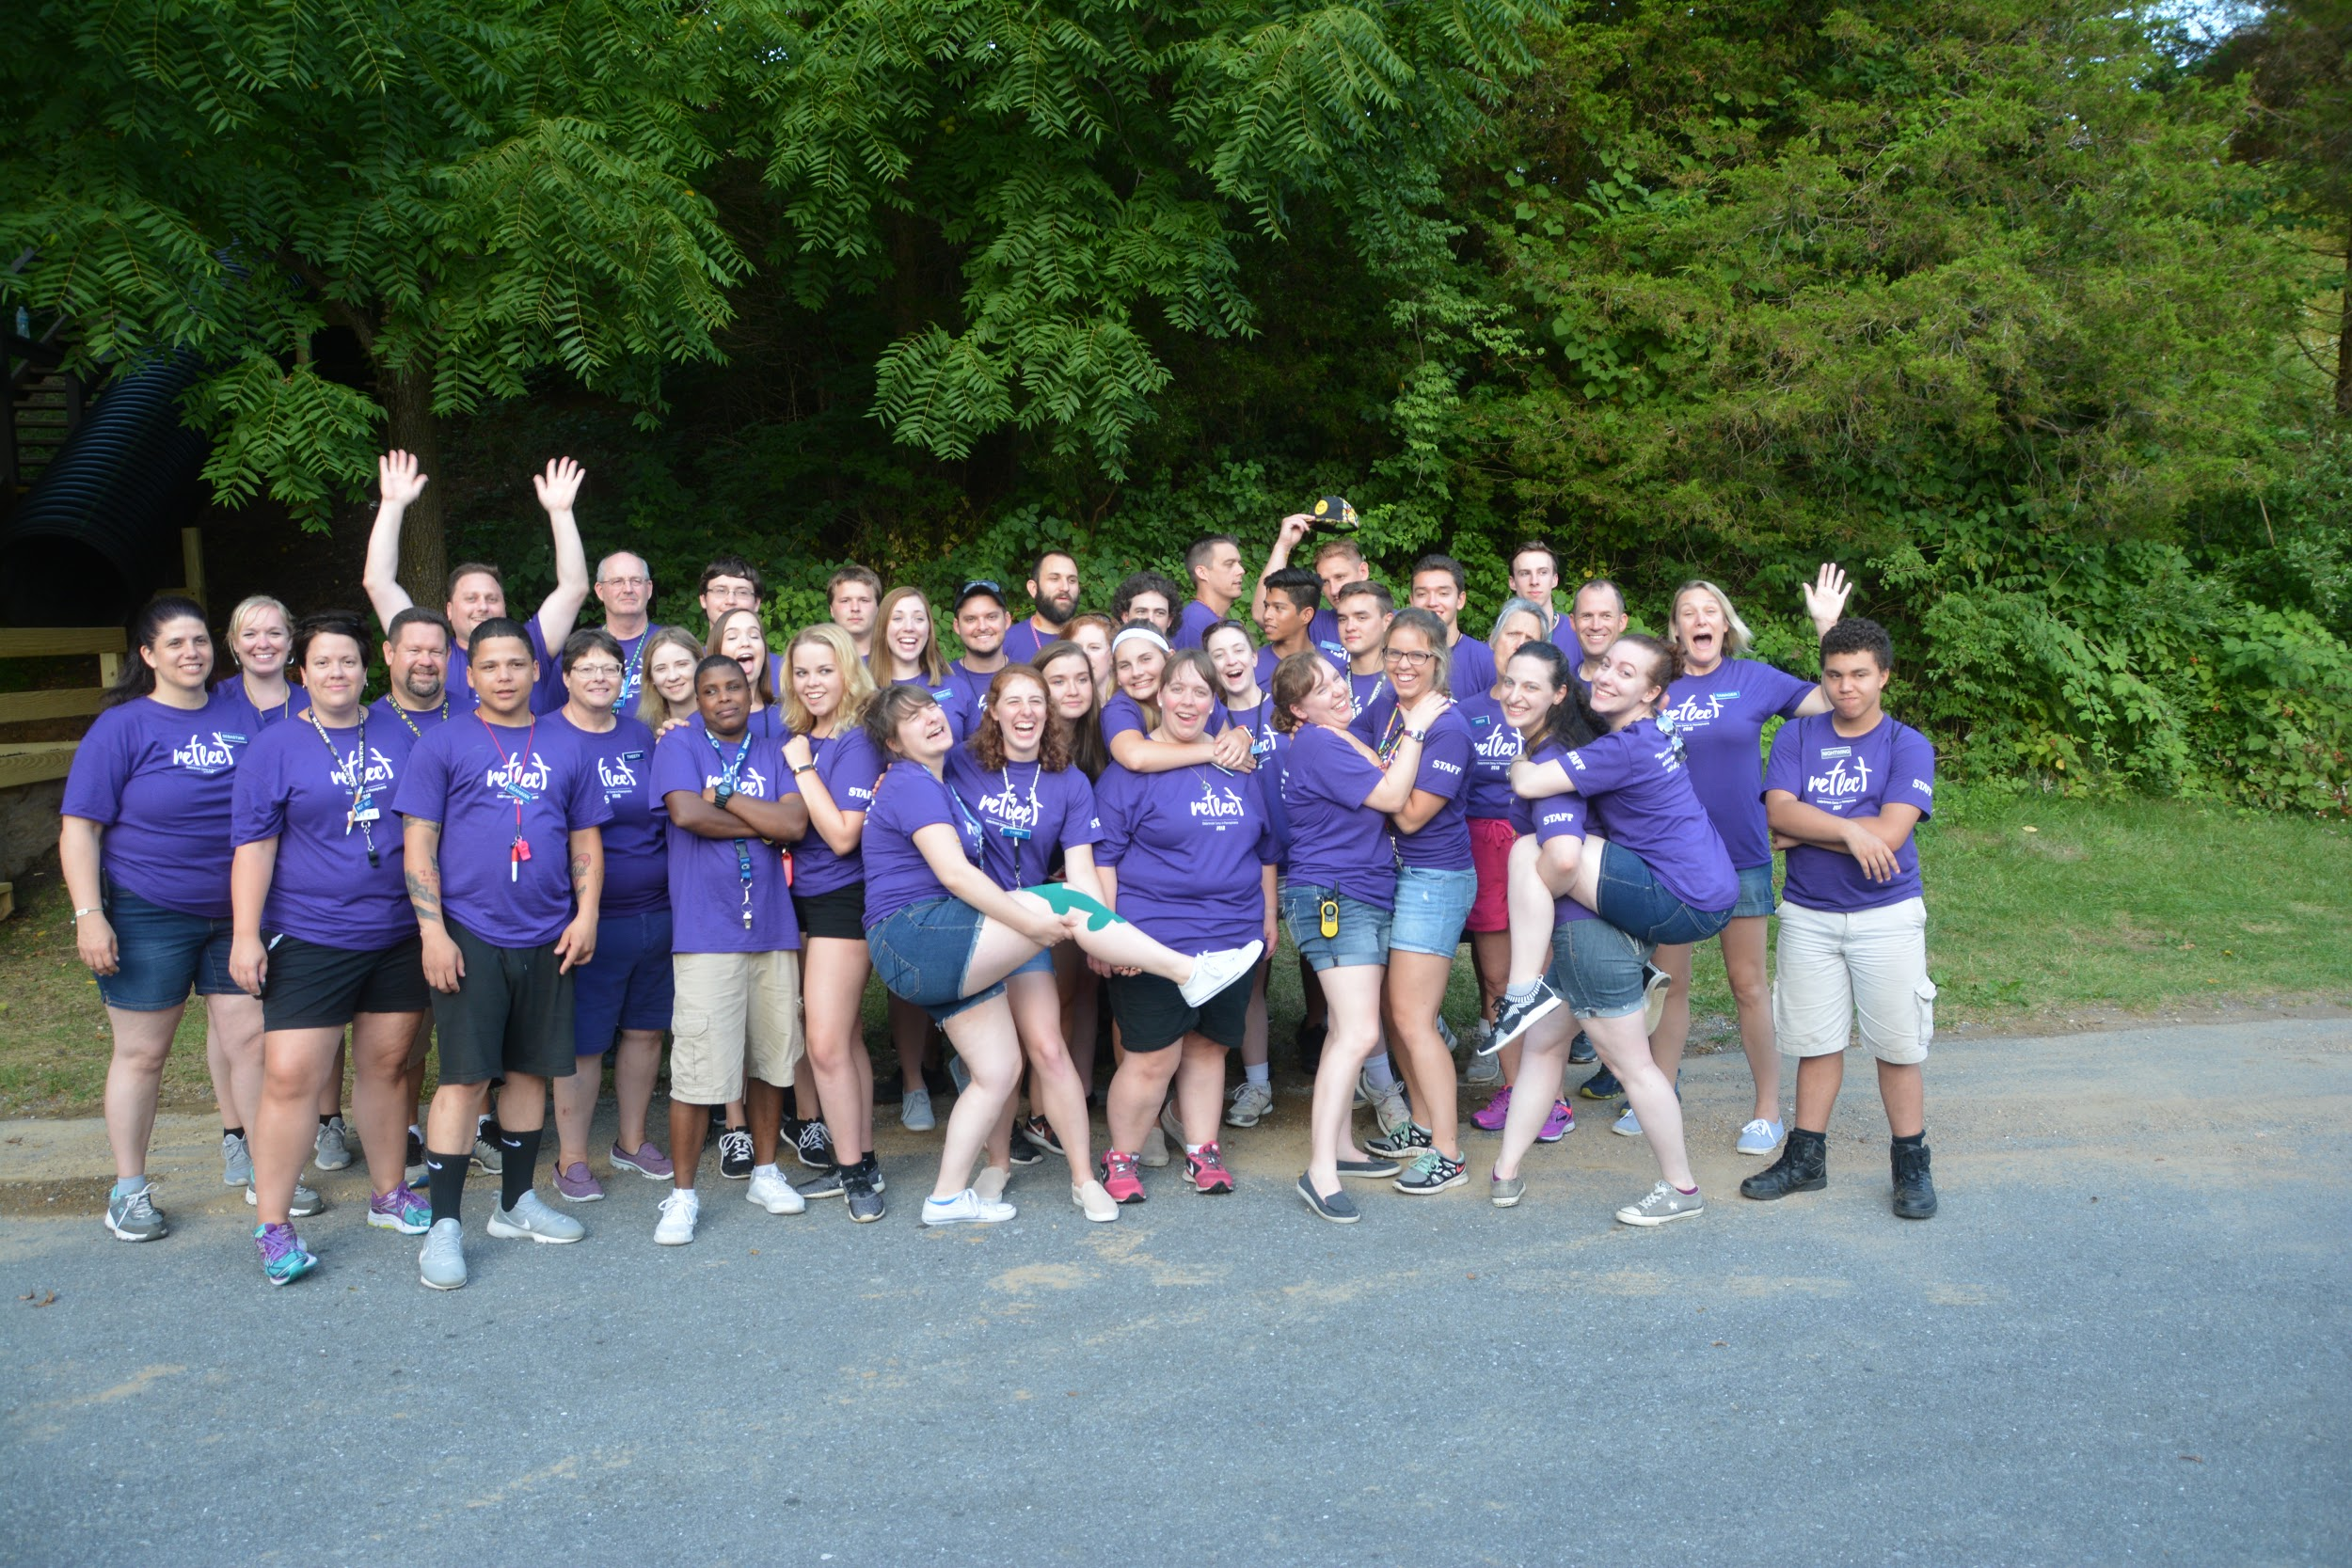

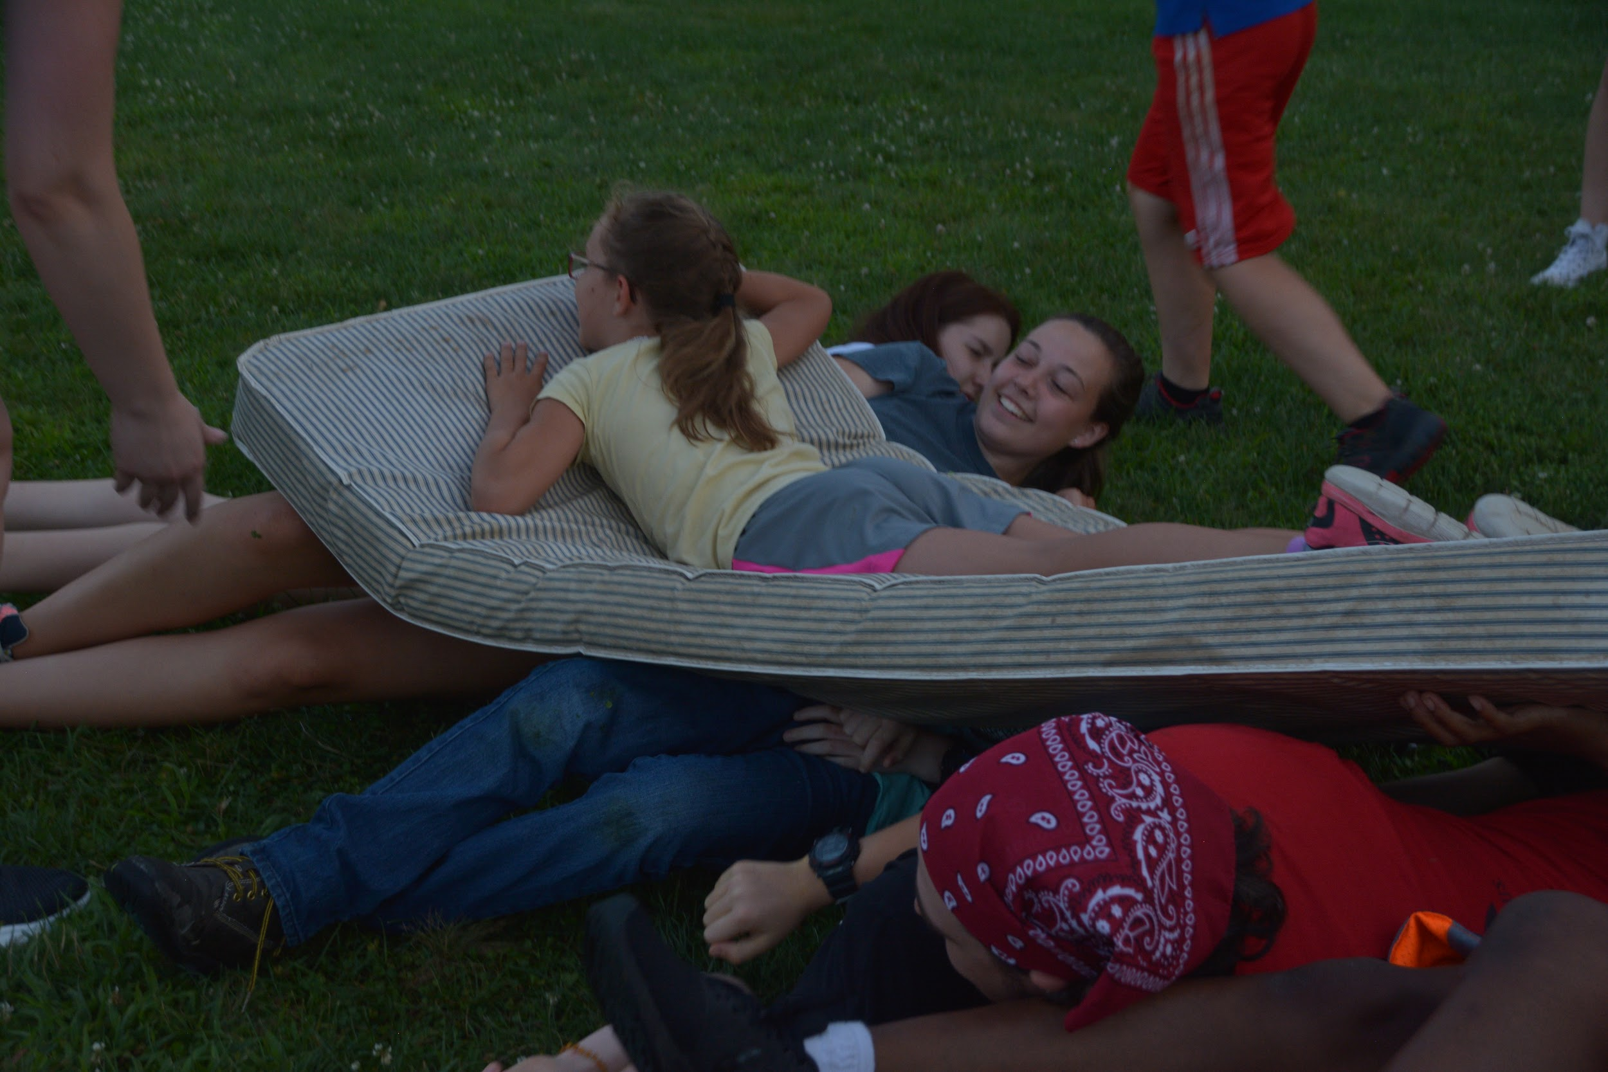
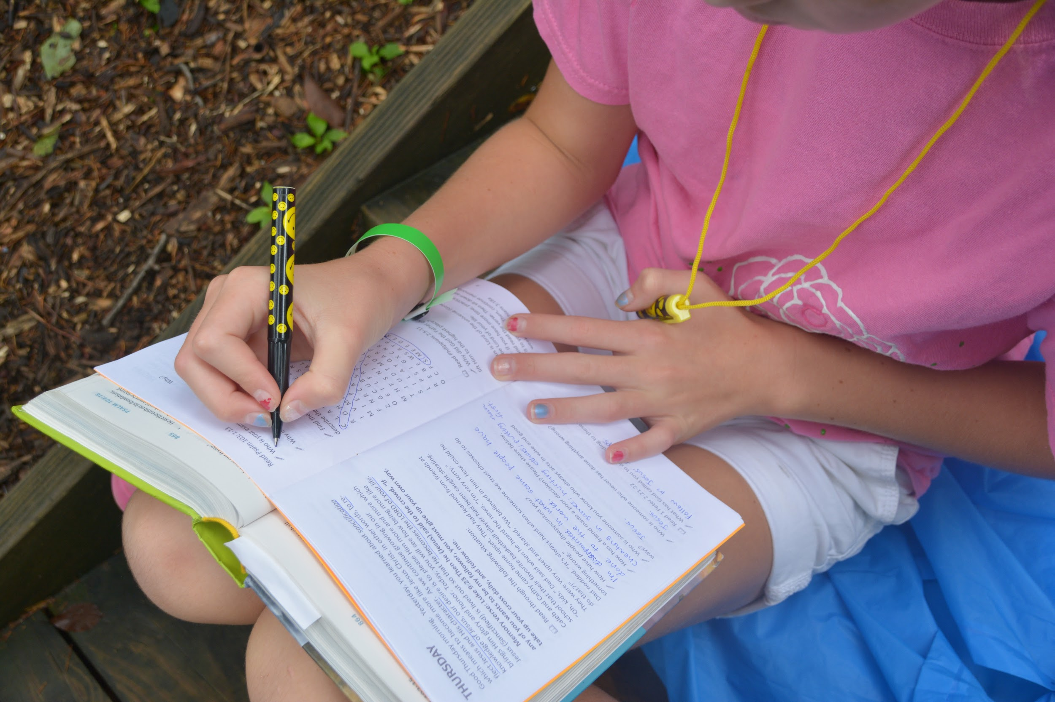
In Christ,

Kelly “Tanager” Sellevaag

