Hi friends of Cedarbrook Camp in PA,
Your Logo Here or delete this text
I want to take this time to thank you for your faithful support through prayer, giving, sending your children to camp, and/or serving at camp. Without you this ministry wouldn’t be possible. God is definitely at move through CCPA and I am so excited to see what He is going to do in the future.
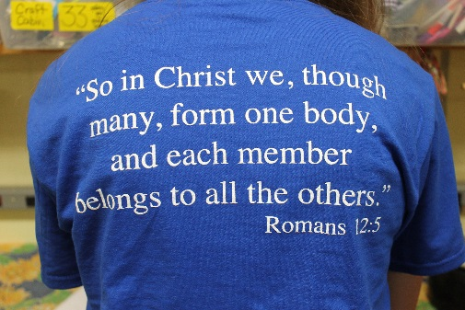
I also wanted to let you know where we stand and tell you a bit about this summer. As most of you know our theme for 2016 was/is “Connected”. We had a wonderful time exploring different ways that you can connect with God and others over the summer. The campfire messages helped us see in tangible ways how we can connect with God and why it is important. We learned that without a connection to God, we are only operating in our own strength which is not much, but when we connect with God amazing things happen!
We had some new things this summer! We had a new head cook who did a wonderful job feeding almost 140 people for our Coed week! That’s a lot of mouths to feed in a small kitchen! We had a large group of CILT graduates (6) and most of the girls were able to stay and serve with us as counselors for girls week. They were a wonderful addition and it is so exciting to see these young people taking steps on faith in the walk with the Lord.
This year we had 146 campers and 55 staff members. Our coed week had a waiting list for campers. Many campers made commitments about deepening their walk with the Lord. We are excited to see how God works in their lives as He draws them into a deeper connection with Him.
2 campers (that we know of) accepted Christ for the first time!!! Praise God!!
We also had some unexpected things happen this summer. Those of you who have been to camp know that it is built on a hill. We have two golf carts to help transport supplies and people who need it around camp. Unfortunately, one of those carts broke and the other one seems like it is on the way out. We ended up needing to rent a golf cart. On our preparation day before campers arrive, our camp printer stopped working so we needed to quickly purchase a new one. These are just some of the unexpected expenses we encountered this summer. Our budget is very tight as it is so we ask that you please pray and consider donating to help cover some of these costs as well as to help keep camper costs as low as we can.

As we near the end of the year, we know that God has blessed us. We celebrate all the work He is doing in us and through us. We know that seeds of the Gospel were planted, watered, and campers and staff were reminded of the connection we have to God through Jesus. We pray that the connection we made with God this summer and with others grows throughout the year.
Again, we thank you for your support. Here are some ways you can continue to support CCPA.
- First and foremost, please pray for us! There is amazing power in prayer!
  - Pray for the campers who made decisions
  - Camp leadership year round including the Board and the directors
  - Our financial situation
  - CILTs as they continue in the program and their year-round assignments
  - Campers who will be with us in 2017
  - Staff who will be joining us in 2017

- Donate. You can use the enclosed envelope to send a donation or donate online at: www.cedarbrookcamppa.org/donate

  - Use AmazonSmile while shopping online
  - If you live in an area that has a Redner’s, please collect your receipts and then mail them to us or bring them to camp.
  - Participate in our 30 days of Thankfulness Campaign

- Serve this summer. Please begin praying about serving with us at CCPA this summer. We would love to have some new cabin counselors and special team members. Our volunteers are critical to running camp! We will train you and support you. Some areas we know we will need some helpers this summer:
  - Cabin staff
  - Kitchen helpers
  - Activity leaders (especially if you have a specific certification or skill)
  - Lifeguards

- Plan to send your child to camp next summer and have them bring a friend. You know how much your kids love camp so have them bring a friend!
2017 Dates:
Coed week July 16-22
Girls week July 23-30

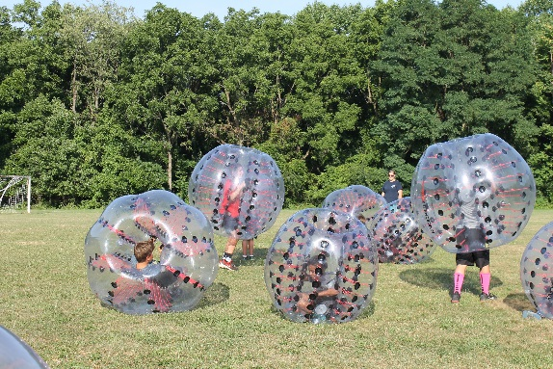
As you can see, there are many ways to get involved and help support CCPA. We know that the Lord is at work through CCPA. Here are some pictures from this summer. Please also visit our webpage to see our video for the year. You can also “like” us on Facebook to see updates and some flashback photos from time to time.

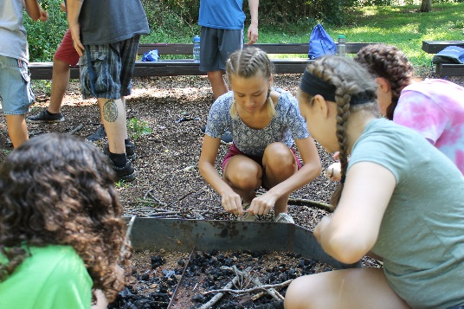
Again, we thank you for your continued support. If we can pray for you in any way, please let us know!

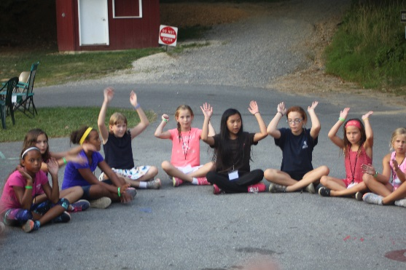

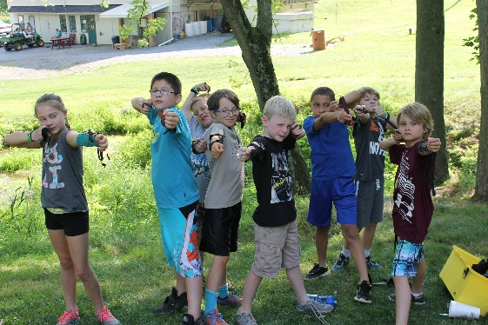

In Christ,

Kelly Sellevaag
Executive Director CCPA

